Romanesque architecture

Romanesque architecture is an architectural style of Medieval Europe, characterized by semi-circular arches and evolving into the gothic style, characterized by pointed arches, beginning in the 12th century. Although there is no consensus for the beginning date of the style, with proposals ranging from the 6th to the 10th centuries, examples can be found across the continent, making Romanesque architecture the first pan-European architectural style since Imperial Roman Architecture. The Romanesque style in England is more traditionally referred to as Norman architecture.
Combining features of Western Roman and byzantine buildings, Romanesque architecture is known by its massive quality, its thick walls, round arches, sturdy piers, groin vaults, large towers and decorative arcading. Each building has clearly defined forms and they are frequently of very regular, symmetrical plan so that the overall appearance is one of simplicity when compared with the Gothic buildings that were to follow. The style can be identified right across Europe, despite regional characteristics and different materials.
Many castles were built during this period, but they are greatly outnumbered by churches. The most significant are the great abbey churches, many of which are still standing, more or less complete and frequently in use.
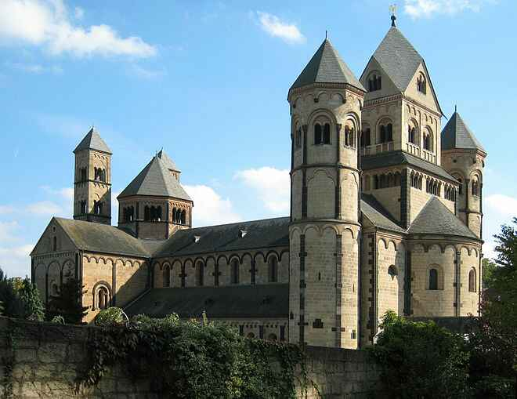
Maria Laach Abbey, Germany

Romanesque architecture was the first distinctive style to spread across Europe since the Roman empire. With the decline of Rome, Roman building methods survived to an extent in Western Europe, where successive Merovingian, Carolingian, and Ottonian architects continued to build large stone buildings such as monastery churches and palaces. In the more northern countries Roman building styles and techniques had never been adopted except for official buildings, while in Scandinavia they were unknown. Although the round arch continued in use, the engineering skills required to vault large spaces and build large domes were lost. there was a loss of stylistic continuity, particularly apparent in the decline of the formal vocabulary of the classical orders. In Rome several great Constantinian basilicas continued in use as an inspiration to later builders. Some traditions of Roman architecture also survived in Byzentium
architecture with the 6th-century octagonal Byzantine Basilica of San Vitale in Ravenna being the inspiration for the greatest building of the dark ages in Europe.

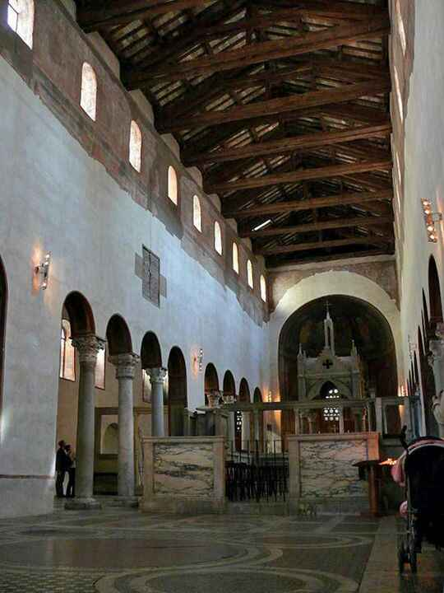

Santa maria in Rome

The general impression given by Romanesque architecture, in both ecclesiastical and secular buildings, is one of massive solidity and strength. In contrast with both the preceding Roman and later Gothic architecture, in which the load-bearing structural members are, or appear to be, columns, pilasters and arches, Romanesque architecture, in common with Byzantine architecture, relies upon its walls, or sections of walls called piers.
Romanesque architecture is often divided into two periods known as the "First Romanesque" style and the "Romanesque" style. The difference is chiefly a matter of the expertise with which the buildings were constructed. The First Romanesque employed rubble walls, smaller windows and unvaulted roofs. A greater refinement marks the Second Romanesque, along with increased use of the vault and dressed stone

Walls
The walls of Romanesque buildings are often of massive thickness with few and comparatively small openings. They are often double shells, filled with rubble.
The building material differs greatly across Europe, depending upon the local stone and building traditions. In Italy, Poland, much of Germany and parts of the Netherlands, brick is generally used. Other areas saw extensive use of limestone, granite and flint. The building stone was often used in comparatively small and irregular pieces, bedded in thick mortar. Smooth ashlar masonry was not a distinguishing feature of the style, particularly in the earlier part of the period, but occurred chiefly where easily worked limestone was available.
Buttresses
Because of the massive nature of Romanesque walls, buttresses are not a highly significant feature, as they are in Gothic architecture. Romanesque buttresses are generally of flat square profile and do not project a great deal beyond the wall.
In the cases where half-barrel vaults were used, they effectively became like flying buttresses. Often aisles extended through two storeys, rather than the one usual in Gothic architecture, so as to better support the weight of a vaulted nave. In the case of Durham Cathedral, flying buttresses have been employed, but are hidden inside the triforium gallery.
- Walls and buttresses
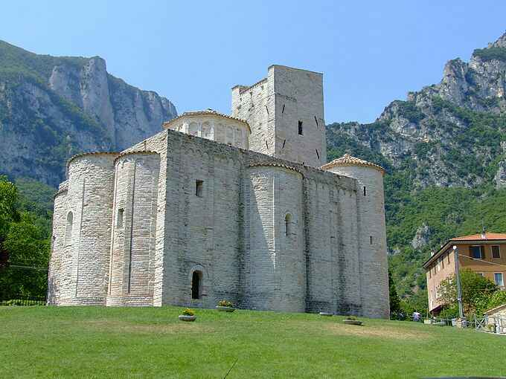

The monastery of San Vittore alle Chiuse,Genga, Italy, of undressed stone, has a typically fortress-like appearance with small windows of early Romanesque

Arches and openings
The arches used in Romanesque architecture are nearly always semicircular, for openings such as doors and windows, for vaults and for arcades. Wide doorways are usually surmounted by a semi-circular arch, except where a door with a lintel.is set into a large arched recess and surmounted by a semi-circular "lunette" with decorative carving.These doors sometimes have a carved central jamb.

Narrow doors and small windows might be surmounted by a solid stone lintel. Larger openings are nearly always arched. A characteristic feature of Romanesque architecture, both ecclesiastic and domestic, is the pairing of two arched windows or arcade openings, separated by a pillar or colonette and often set within a larger arch. Ocular windows are common in Italy, particularly in the facade gable and are also seen in Germany. Later Romanesque churches may have wheel windows or rose windows with plate tracery.
There are a very small number of buildings in the Romanesque style, such as Autunin cathedral France and Monreale cathedral in Sicily in which pointed arches have been used extensively, apparently for stylistic reasons. It is believed that in these cases there is a direct imitation of Islamic architecture . At other late Romanesque churches such as DDurham cathedral, and Cafalu Cathedral, the pointed arch was introduced as a structural device in ribbed vaulting. Its increasing application was fundamental to the development of Gothic architecture
Arcades
An arcade is a row of arches, supported on piers or columns. They occur in the interior of large churches, separating the nave from the aisles, and in large secular interiors spaces, such as the great hall of a castle, supporting the timbers of a roof or upper floor. Arcades also occur in cloisters and atriums, enclosing an open space.
Arcades can occur in storeys or stages. While the arcade of a cloister is typically of a single stage, the arcade that divides the nave and aisles in a church is typically of two stages, with a third stage of window openings known as the clerestory rising above them. Arcading on a large scale generally fulfils a structural purpose, but it is also used, generally on a smaller scale, as a decorative feature, both internally and externally where it is frequently "blind arcading" with only a wall or a narrow passage behind it.
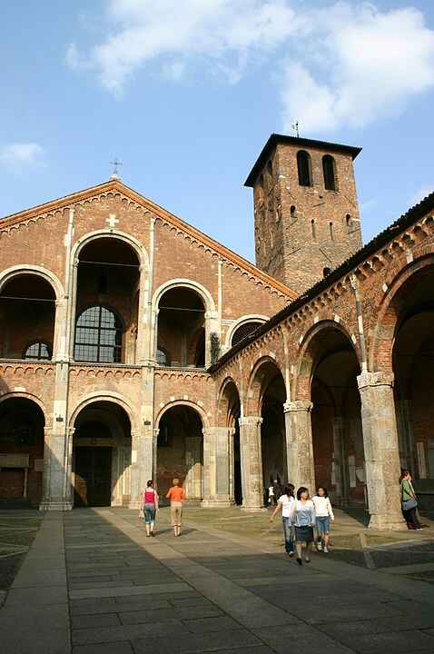

The atrium and arcaded narthex of Sant'Ambrogio, Milan, Italy, is a harmonious composition of similar arches.

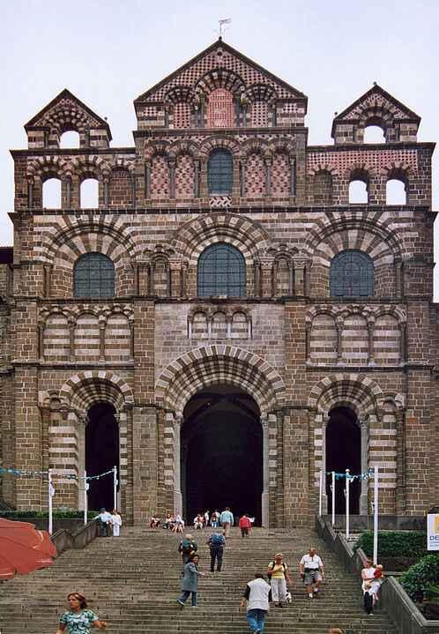

The facade of Notre Dame du Puy, le Puy en Velay, France, has a more complex arrangement of diversified arches: Doors of varying widths, blind arcading, windows and open arcades
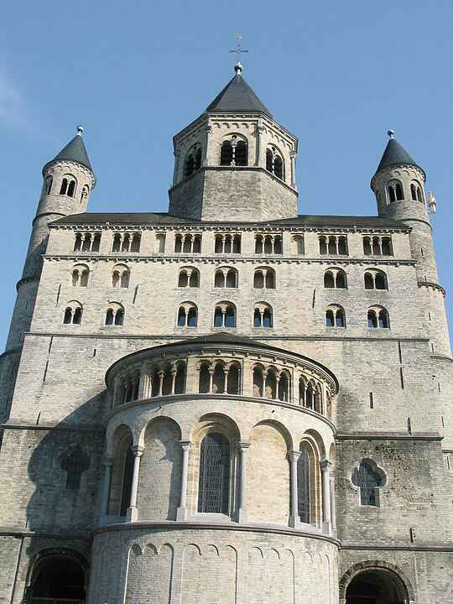
Collegiate Church of Saint Gertrude, Nivelles,Belgium uses fine shafts of Belgian marble to define alternating blind openings and windows. Upper windows are similarly separated into two openings by colonett

Piers
In Romanesque architecture, piers were often employed to support arches. They were built of masonry and square or rectangular in section, generally having a horizontal moulding representing a capital at the springing of the arch. Sometimes piers have vertical shafts attached to them, and may also have horizontal mouldings at the level of the base.
Although basically rectangular, piers can often be of highly complex form, with half-segments of large hollow-core columns on the inner surface supporting the arch, or a clustered group of smaller shafts leading into the mouldings of the arch.
Piers that occur at the intersection of two large arches, such as those under the crossing of the nave and transept, are commonly cruciform in shape, each arch having its own supporting rectangular pier at right angles to the othe
Columns
Columns are an important structural feature of Romanesque architecture. Colonnettes and attached shafts are also used structurally and for decoration. Monolithic columns cut from a single piece of stone were frequently used in Italy, as they had been in Roman and Early Christian architecture.They were also used, particularly in Germany, when they alternated between more massive piers. Arcades of columns cut from single pieces are also common in structures that do not bear massive weights of masonry, such as cloisters, where they are sometimes paired.

Salvaged columns
In Italy, during this period, a great number of antique Roman columns were salvaged and reused in the interiors and on the porticos of churches. The most durable of these columns are of marble and have the stone horizontally bedded. The majority are vertically bedded and are sometimes of a variety of colours. They may have retained their original Roman capitals, generally of the Corinthian or Roman composite style. Some buildings, like Santa Maria (illustrated above)and the atrium at San Clemente in Rome, may have an odd assortment of columns in which large capitals are placed on short columns and small capitals are placed on taller columns to even the height. Architectural compromises of this type are seen where materials have been salvaged from a number of buildings. Salvaged columns were also used to a lesser extent in France.

Drum columns
In most parts of Europe, Romanesque columns were massive, as they supported thick upper walls with small windows, and sometimes heavy vaults. The most common method of construction was to build them out of stone cylinders called drums, as in the crypt at Speyer cathdral.

Hollow core columns
Where really massive columns were called for, such as those at Durham Cathedral, they were constructed of ashlar masonry and the hollow core was filled with rubble. These huge untapered columns are sometimes ornamented with incised decorations.
Alternation
A common characteristic of Romanesque buildings, occurring both in churches and in the arcades that separate large interior spaces of castles, is the alternation of piers and columns.
The most simple form that this takes is to have a column between each adjoining pier. Sometimes the columns are in multiples of two or three. At St. Michael'sHildeseim.
There are tall drum columns between piers each of which has a half-column supporting the arch. There are many variations on this theme, most notably at Durham Cathedral where the mouldings and shafts of the piers are of exceptional richness and the huge masonry columns are deeply incised with geometric patterns.
Often the arrangement was made more complex by the complexity of the piers themselves, so that it was not piers and columns that alternated, but rather, piers of entirely different form from each other, such as those of Saint Ambtogio Milan. where the nature of the vault dictated that the alternate piers bore a great deal more weight than the intermediate ones and are thus very much larger.

Piers and columns

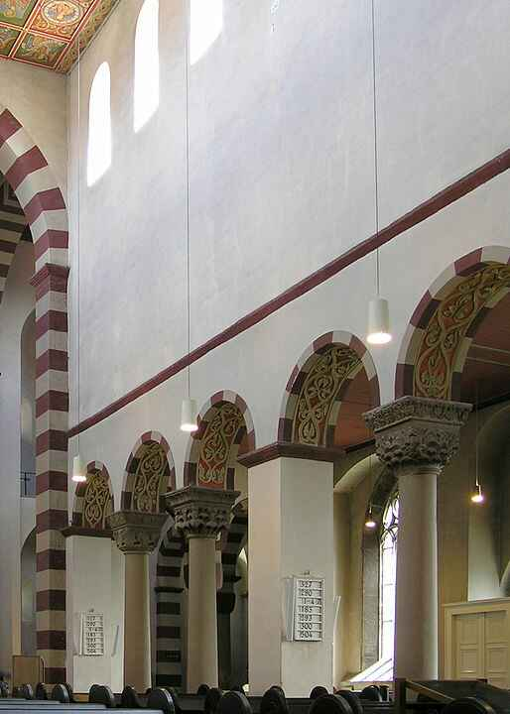
St Michael's, Hildesheim, shows two columns set between the piers.
t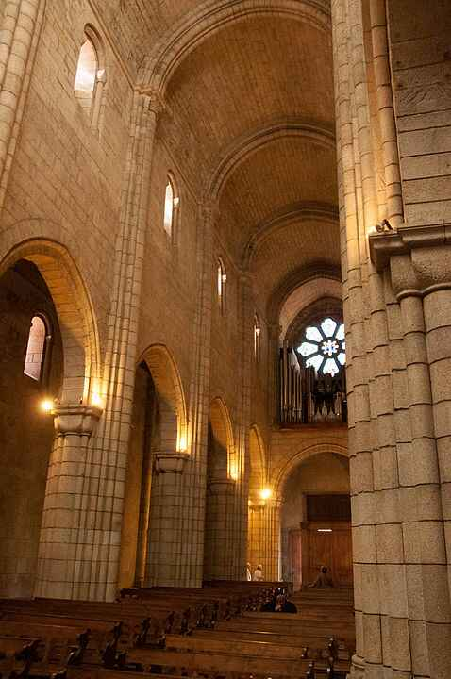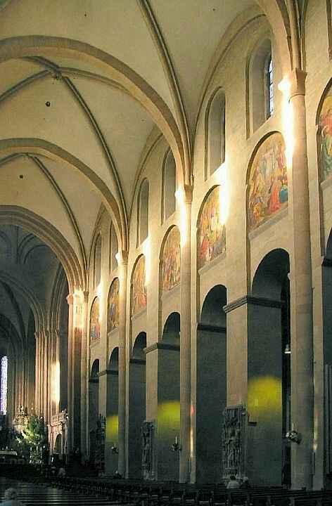

Mainz Cathedral, Germany, has rectangular piers and possibly the earliest example of an internal elevation of 3 stages. (Gothic vault)

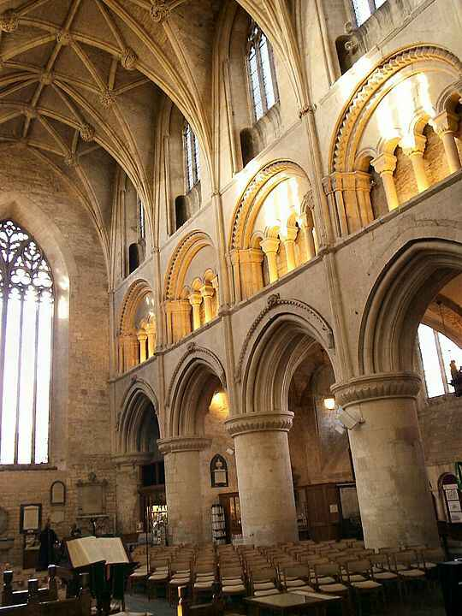
Malmesbury Abbey, England, has hollow core columns, probably filled with rubble. (Gothic vault

Porto Cathedral, Portugal. The nave barrel vaulting is supported by thick heavy column

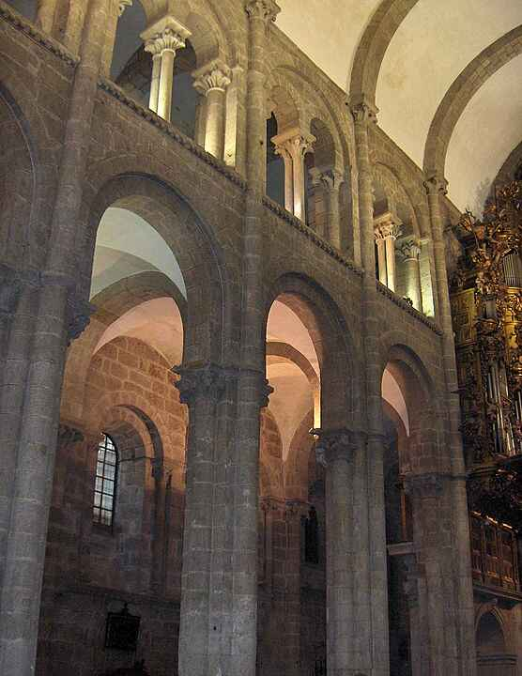
The cathedral of Santiago de Compostela, Spain, has large drum columns with attached shafts supporting a barrel vault.

Capitals
The foliate Corinthian style provided the inspiration for many Romanesque capitals, and the accuracy with which they were carved depended very much on the availability of original models, those in Italian churches such as Pisa Cathedral
The Corinthian capital is essentially round at the bottom where it sits on a circular column and square at the top, where it supports the wall or arch. This form of capital was maintained in the general proportions and outline of the Romanesque capital. This was achieved most simply by cutting a rectangular cube and taking the four lower corners off at an angle so that the block was square at the top, but octagonal at the bottomThis shape lent itself to a wide variety of superficial treatments, sometimes foliate in imitation of the source, but often figurativeWhile some are dependent on manuscripts illustrations of Biblical scenes and depictions of beasts and monsters, others are lively scenes of the legends of local saints.
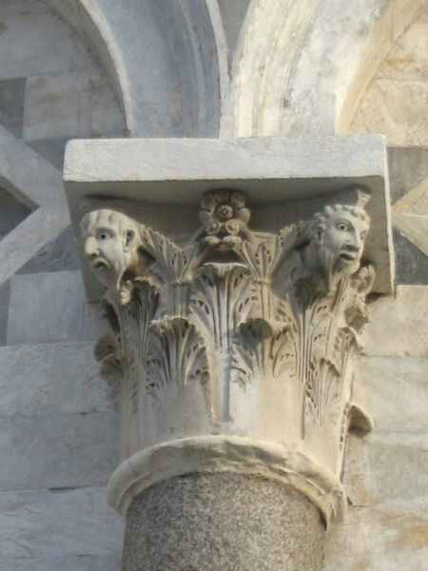
Capital of Corinthian form with anthropomorphised details,Pisa Campanil

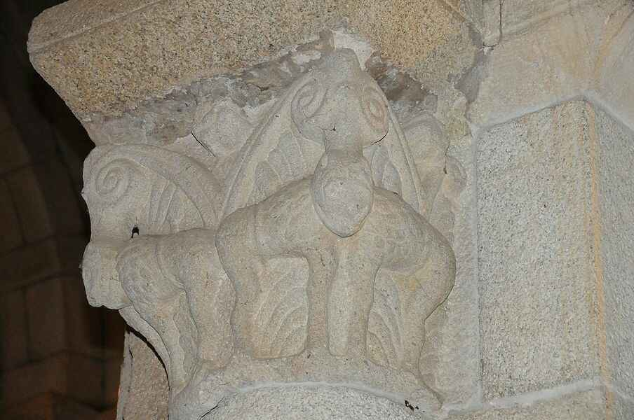

Capital of primitive Corinthian form decorated with theBiblical scene of Daniel in a hole with lions, Monastery of Paço de Sousa, Portugal.
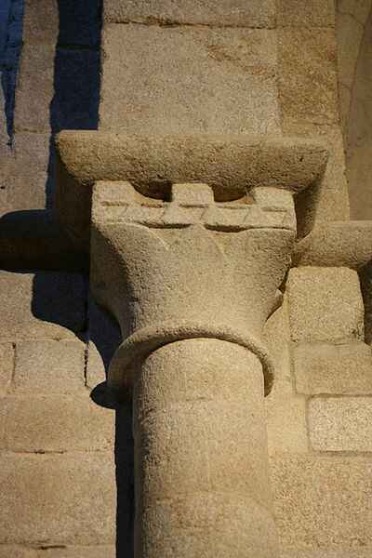
Capital of simplified concave Corinthian form with billetedabacus, simple dosseret and pronounced annulet. Church of Santa Maria, San Martín de Castañeda

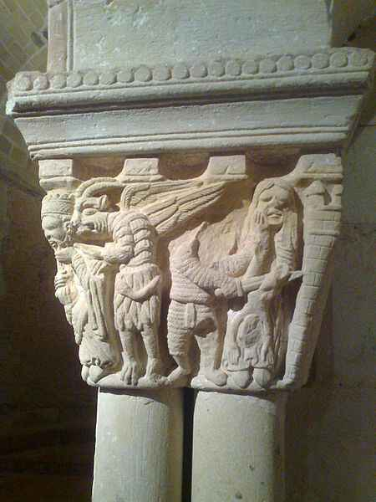
Capital of amorphous form surmounting a cluster of shafts. The figurative carving shows a winged devil directing Herod to slaughter the Innocents. Monastery of San juande Duero, Soria

Vaults
Vaults of stone or brick took on several different forms and showed marked development during the period, evolving into the pointed ribbed arch characteristic ofGothoc architecture.
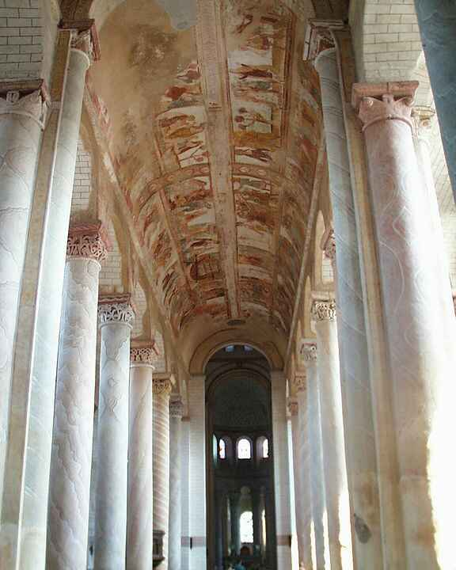
The painted barrel vault at the Abbey Church of Saint-Savin-sur-Gartempe is supported on tall marbled columns.

Barrel vault
The simplest type of vaulted roof is the barrel vault in which a single arched surface extends from wall to wall, the length of the space to be vaulted, for example, the nave of a church. An important example, which retains Medieval paintings, is the vault of Saint Savin SurGartempe, France, of the early 12th century. However, the barrel vault generally required the support of solid walls, or walls in which the windows were very small.
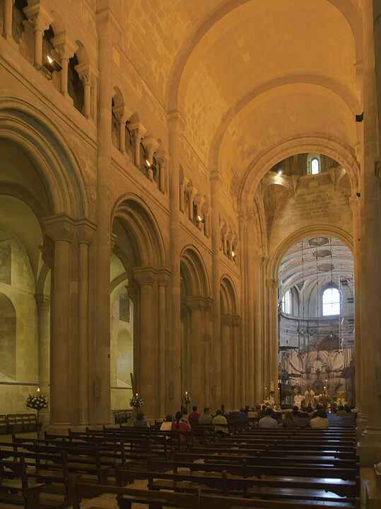
The nave of Lisbon Cathedral is covered by barrel vaulting and has an upper, arched gallery (triforium).

Groin vault
Groin vaults occur in early Romanesque buildings, notably at Speyer Cathdral where the high vault of about 1060 is the first employment in Romanesque architecture of this type of vault for a wide nave. In later buildings employing ribbed vaultings, groin vaults are most frequently used for the less visible and smaller vaults, particularly in crypts and aisles. A groin vault is almost always square in plan and is constructed of two barrel vaults intersecting at right angles. Unlike a ribbed vault, the entire arch is a structural member. Groin vaults are frequently separated by transverse arched ribs of low profile as at Speyer and Santiago de compostela. At Saint Marry, the ribs are square in section, strongly projecting and polychrome.

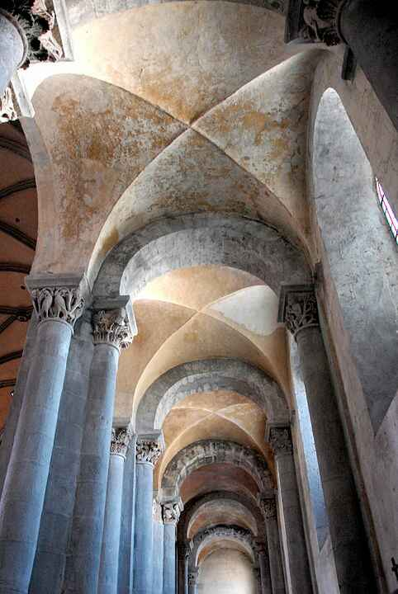
The aisle of the Abbey Church at Mozac has a groin vault supported on transverse arches.

Ribbed vault
Ribbed vaults came into general use in the 12th century. In ribbed vaults, not only are there ribs spanning the vaulted area transversely, but each vaulted bay has diagonal ribs, following the same course as the groins in a groin vault. However, whereas in a groin vault, the vault itself is the structural member, in a ribbed vault, it is the ribs that are the structural members, and the spaces between them can be filled with lighter, non-structural material.
Because Romanesque arches are nearly always semi-circular, the structural and design problem inherent in the ribbed vault is that the diagonal span is larger and therefore higher than the transverse span. The Romanesque builders used a number of solutions to this problem. One was to have the centre point where the diagonal ribs met as the highest point, with the infill of all the surfaces sloping upwards towards it, in a domical manner. This solution was employed in Italy at San Michele,Pavia, and Sant Ambrogio, Milan.
The solution employed in England was to stilt the transverse ribs, maintaining a horizontal central line to the roof like that of a barrel vault. The diagonal ribs could also be depressed, a solution used on the sexpartite vaults at both the Saint-Étienne, and Sainte-Trinité, at Caen, France, in the late 11th and early 12th centuries.

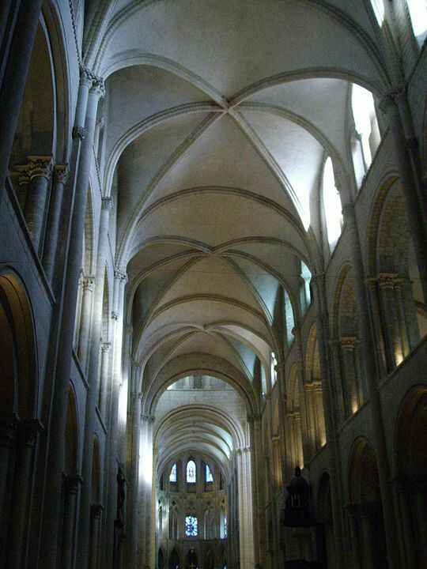

The ribbed vaults at Saint-Étienne, Caen, are sexpartite and span two bays of the nave.

Pointed arched vault
The problems encountered in the structure and appearance of vaults was solved late in the Romanesque period with the introduction of pointed arched ribs which allowed the height of both diagonal and transverse ribs to be varied in proportion to each other.Pointed ribs made their first appearance in the transverse ribs of the vaults at Durham Cathedral in northern England, dating from 1128. Durham is a cathedral of massive Romanesque proportions and appearance, yet its builders introduced several structural features that were new to architectural design and were later to be hallmark features of the Gothic. Another Gothic structural feature employed at Durham is the flying buttress. However, these are hidden beneath the roofs of the aisles. The earliest pointed vault in France is that of the narthex of La Madeleine, Vezelay, dating from 1130.They were subsequently employed with the development of the Gothic style at the east end of theBasillica of St Denis in Paris in 1140. An early ribbed vault in the Romanesque architecture of Sicily is th

